DOCKER ASSIGNMENT-1

**Question**: From a GITHUB repo having 4 branches 2024 Q1,Q2,Q3,Q4 having file index.html should be launched on Jenkins master with different ports using port binding functionality of container like 80, 90, 8001, 8090 respectively using container created with httpd container

==========================

* Launce a ec2 instance
* Install java 11
* Install Tomcat
* Download Jenkins war file in webapps folder of Tomcat and start the Tomcat.
* Create a Github repo with 4 branches as shown is SS below and insert a index.html file in it.

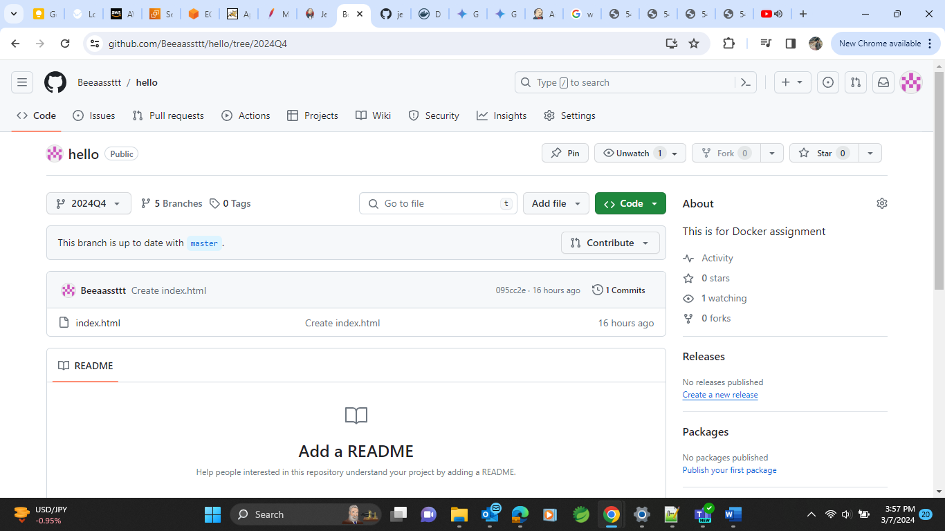

* After all the configurations as per shown in previous docs of Jenkins assignment we will be able to see Jenkins UI like this.

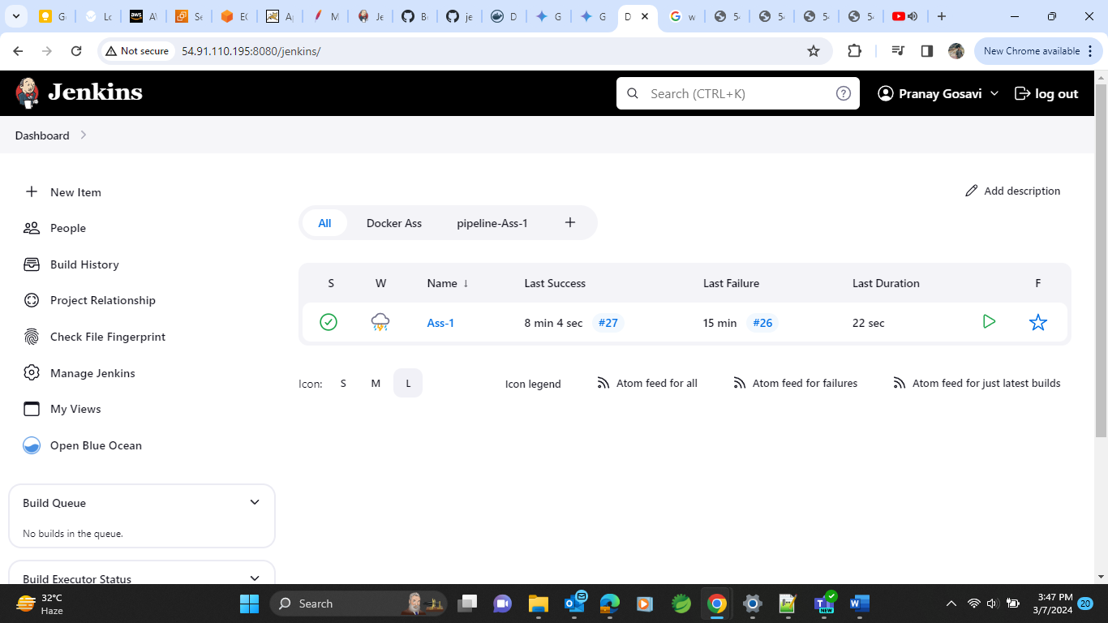

* Create a job here with pipeline option named as Ass-1 for assignment 1
* Choose the options as show in SS shown below

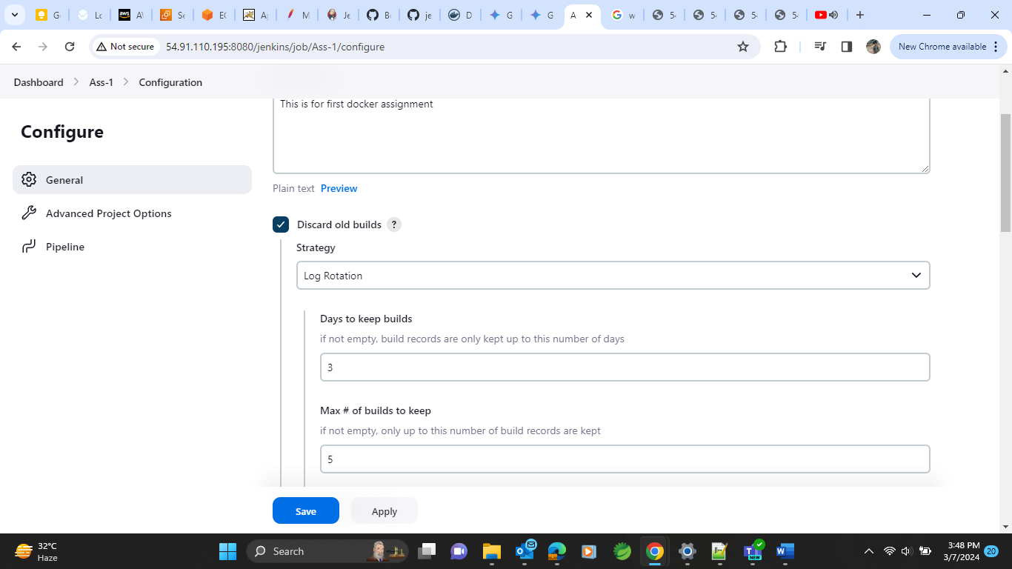

* In Definition select pipeline script and provide it with our groovy syntax of whatever the requirement it is (here the requirement is as per the question mentioned)
* Click ok “Build job” and it is build successfully

* We could now see result as we aimed to see index.html file to be deployed on multiple ports of containers having 80 port of container which would be enabled by port binding functionality.
* We could be able to see ,
* **2024Q1 running on port 80**

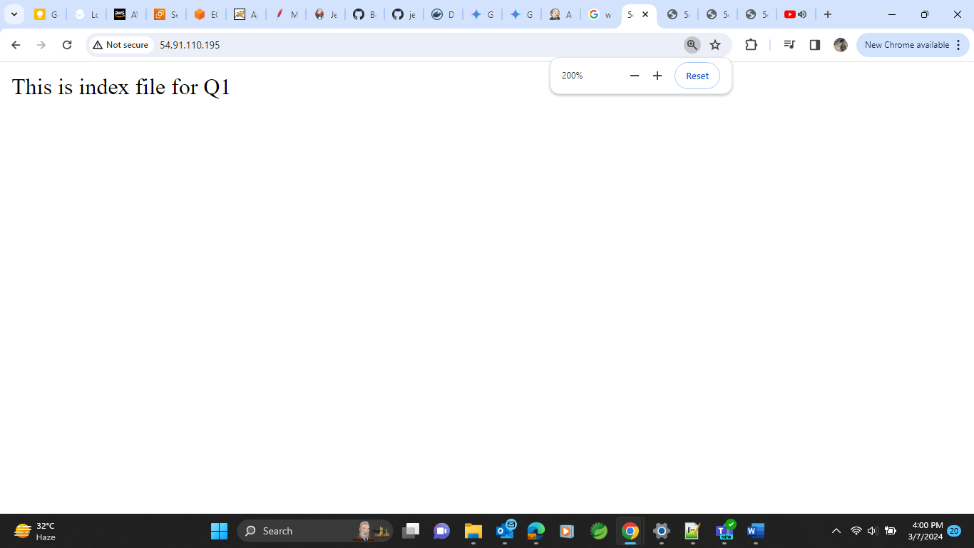

* **2024Q2 running on port 90**

* **2024Q3 running on port 8001**

* **2024Q4 running on port 8090**

* Add all those ports in Security Group of ec2 instances to access them on browser.